Sequence Diagram: Group Participation
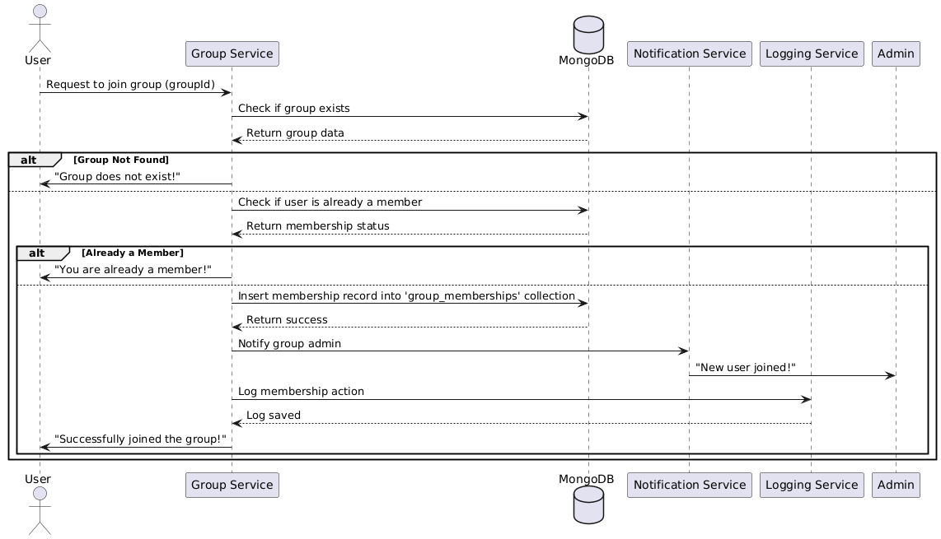

Database
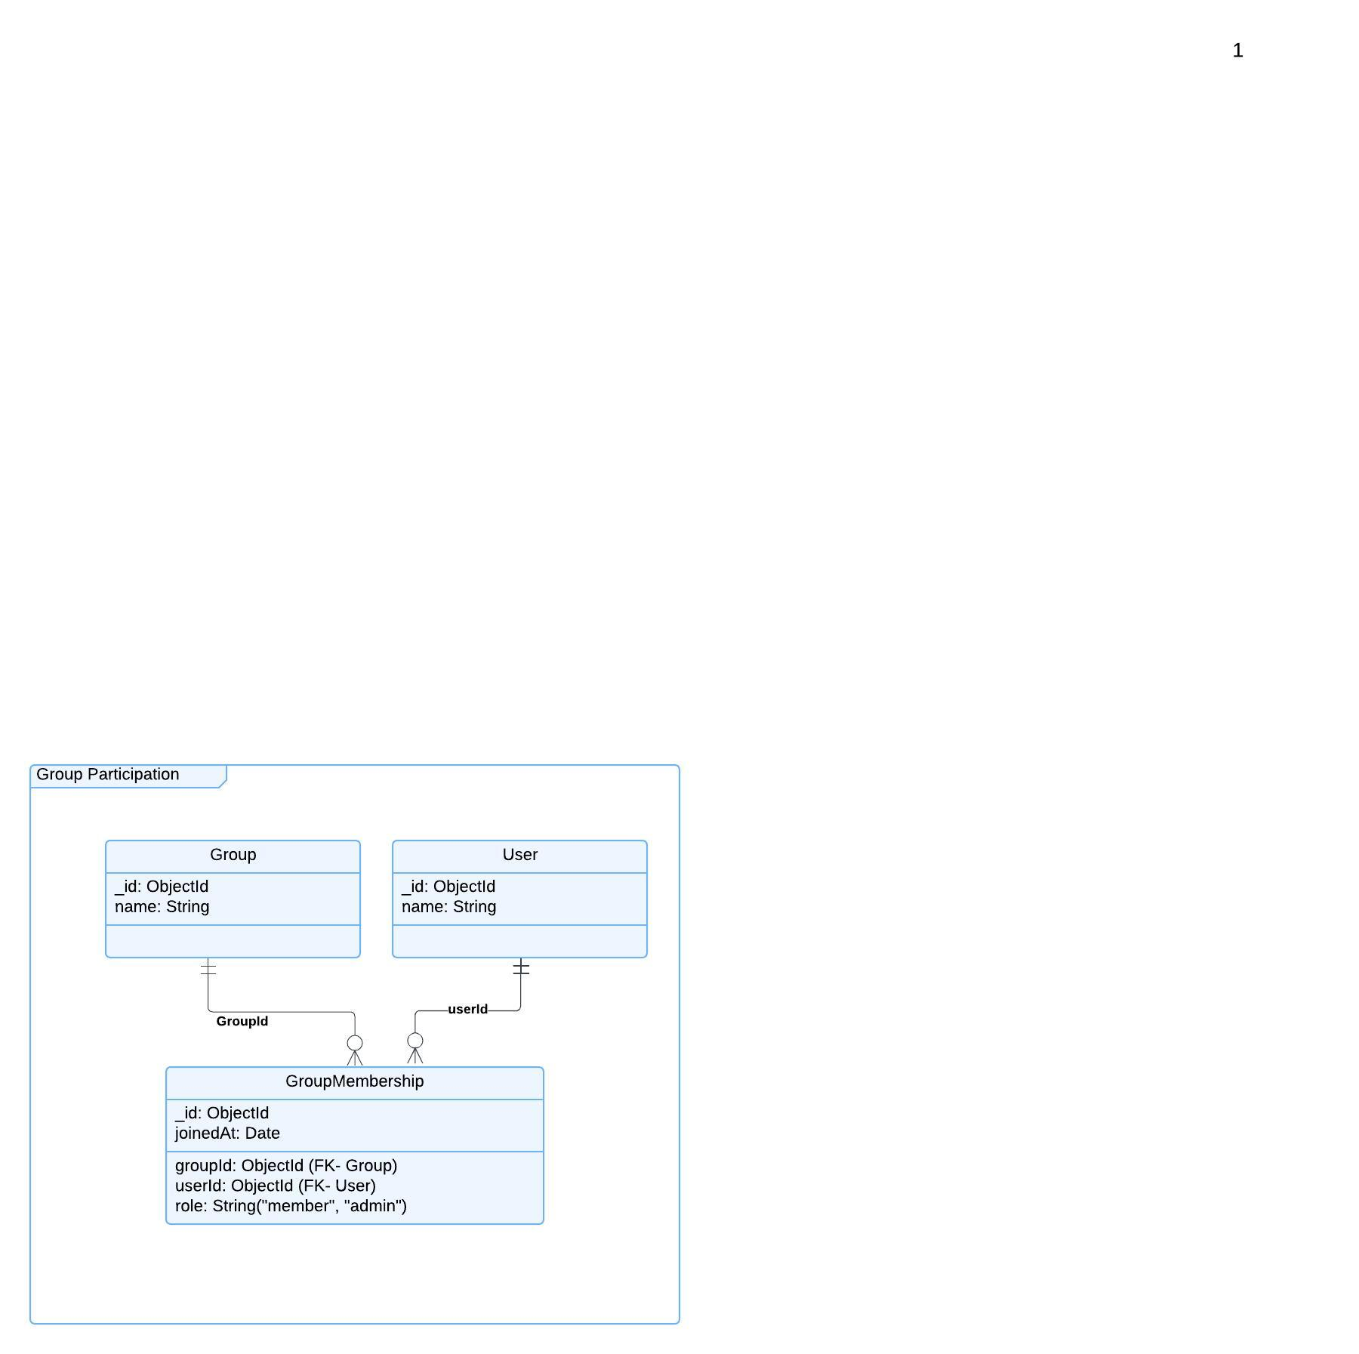

Functional Requirements (FRs)
FR1: The system shall allow users to join groups.
FR2: The system shall allow group admins to manage memberships (approve/reject users for private groups).
FR3: The system shall support different roles within a group (member, admin).
FR4: Users shall be able to leave a group at any time.

Non-Functional Requirements (NFRs)
NFR1: The system should process membership requests in less than 3 seconds.
NFR2: The system shall support at least 1 million users per group.
NFR3: Group role changes should be logged for security and auditing purposes.

